# Basic Settings

Our Proxy supports configuration on the maximum size of LRU cache. By default, the value would be 10, but you can override this setting by given a fourth parameter when starting the proxy, for example:

./proxy 0.0.0.0 7777 **20**

./proxy 0.0.0.0 7777 **5**

The format for client input is:

./client 0.0.0.0 7777 http://www.google.com/index.html

Due to the constraint of Unix system, the filename cannot contain character ‘/’, thus, our file-naming mechanism will replace all ‘/’ character with ‘_’ character, which works as follows:

For Server:

We use format: **www.xxx.xxx_xxx.ext** to store cache

For Client:

We use format: **datetime_GMT_http:__www.xxx.xxx_xxx.ext** to store transferred file.

The client won’t remove the HTTP header, which means the file cannot be opened directly. A parser or manually remove the header will work in this case. We didn’t implement removing header function is because (a). there is no demand on this assignment; (b). the header is useful for checking how cache operates, especially for distinguishing staled or valid caches.

Since we’ve implemented the bonus feature, we’ll run tests based on BONUS cache refreshing logic.

The Proxy will run at ‘/Server’ folder, and the Client will run at ‘/Test’ folder to tell the difference.

# Test suits

1. We first try 10 HTTP requests and check for cache performance. Then we use ‘diff’ to check the correspondence between cached file and the client-side received file.

After that, we’ll try a request that is cached. Then we will try a request that should not be cached. After that, we’ll try a staled file request. Finally, we’ll try a new cache-required request to see if the cache deletes the least recently used one and add this new request. Below are some phases during operation.

Status Screenshot at transferred 6 files:

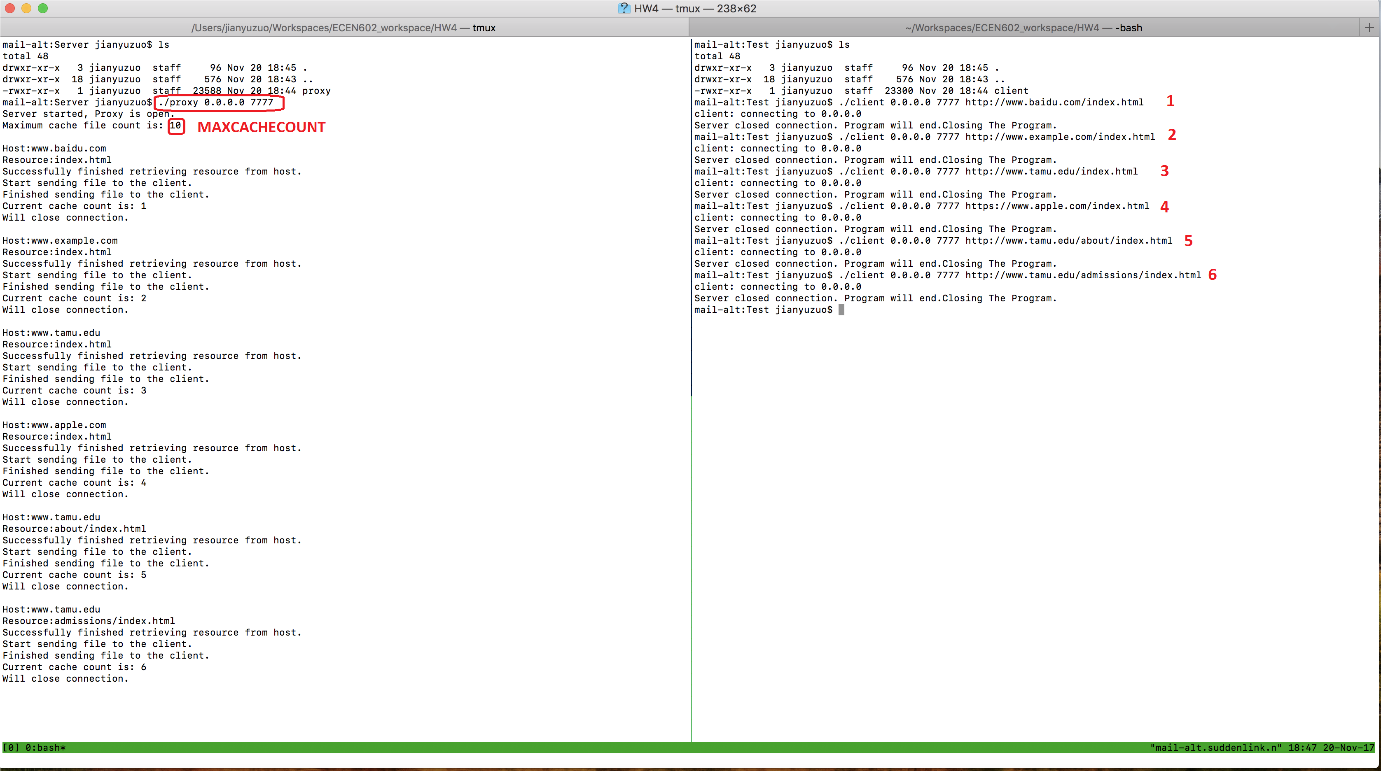

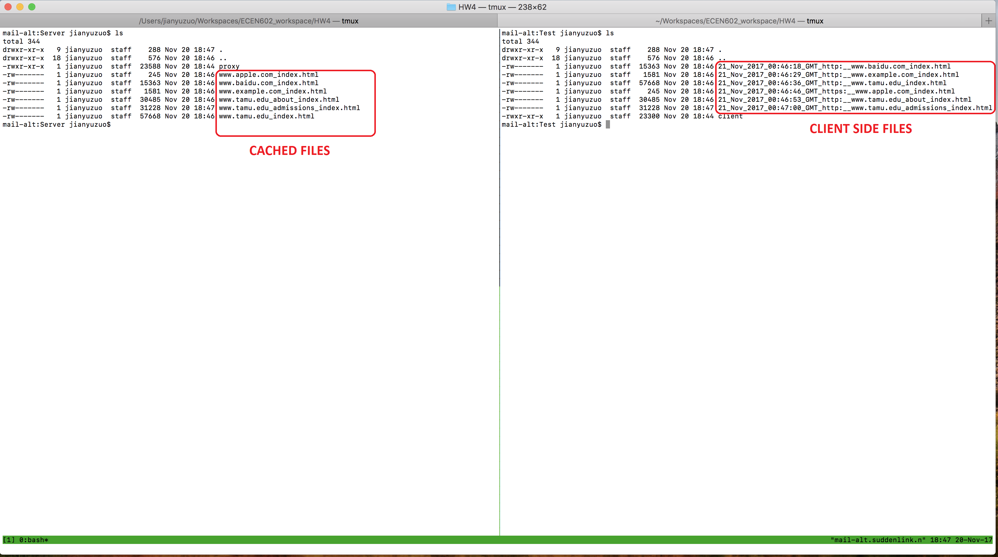

Status Screenshot after transferred 10 files:

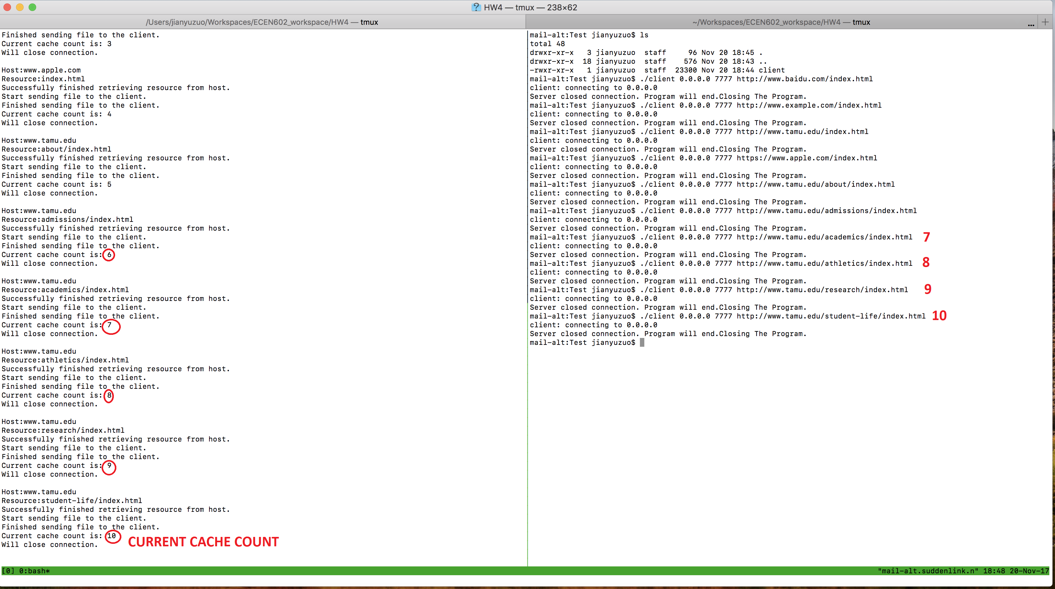

File Comparison between cache and client received files:

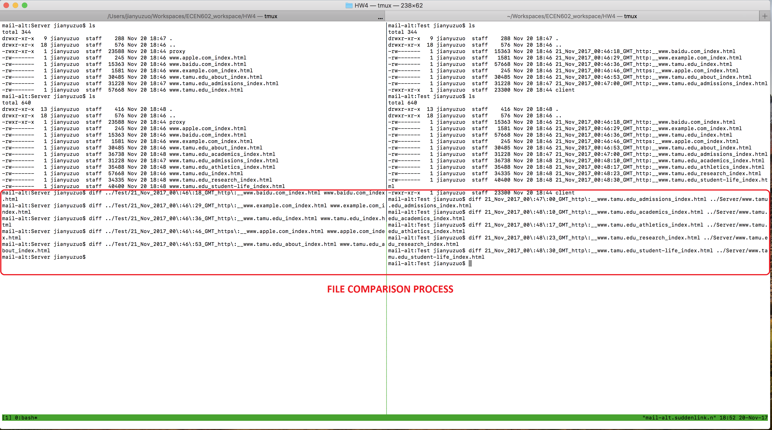

For now, the cache is full.

Next, after trying a valid cached request:

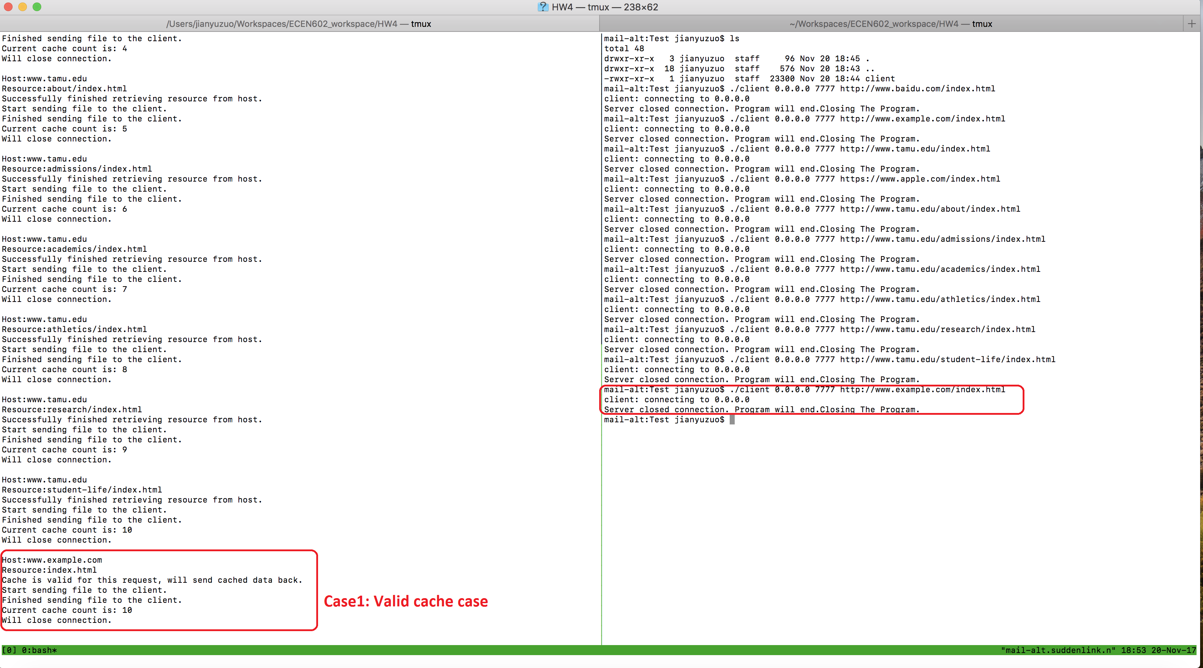

After trying a request that should not be cached:

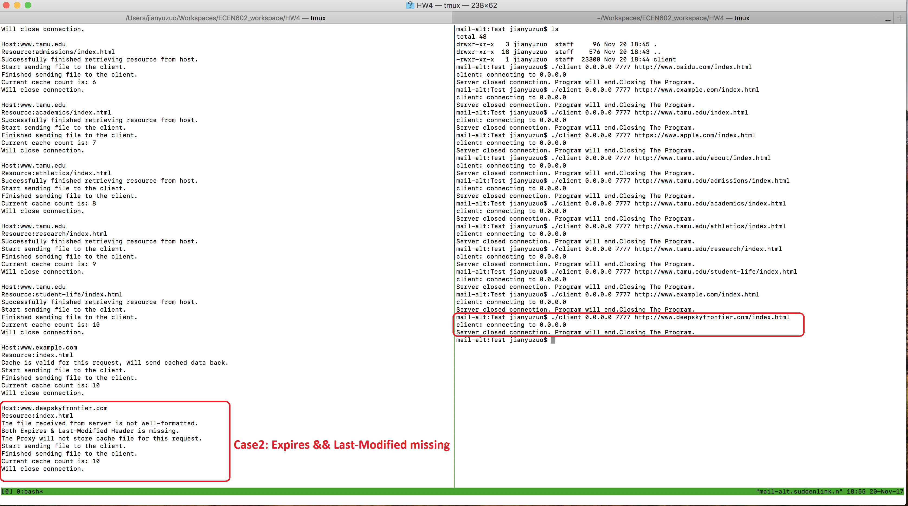

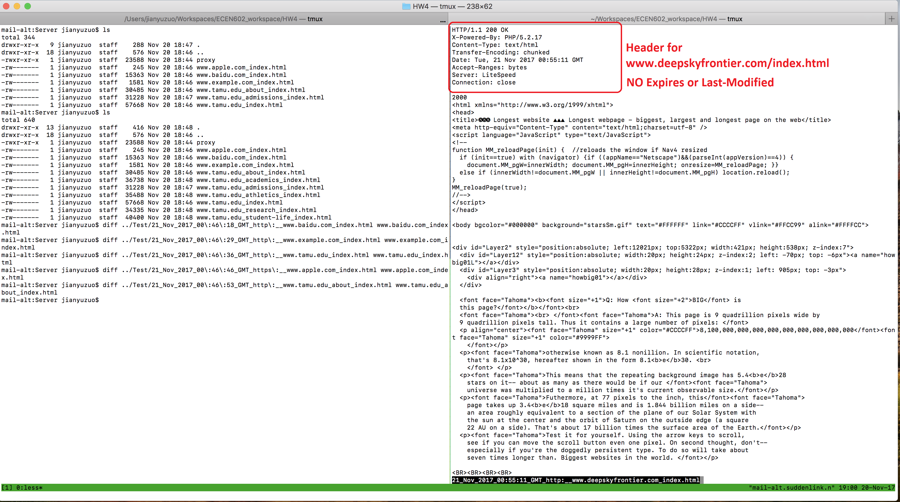

After trying a staled request:

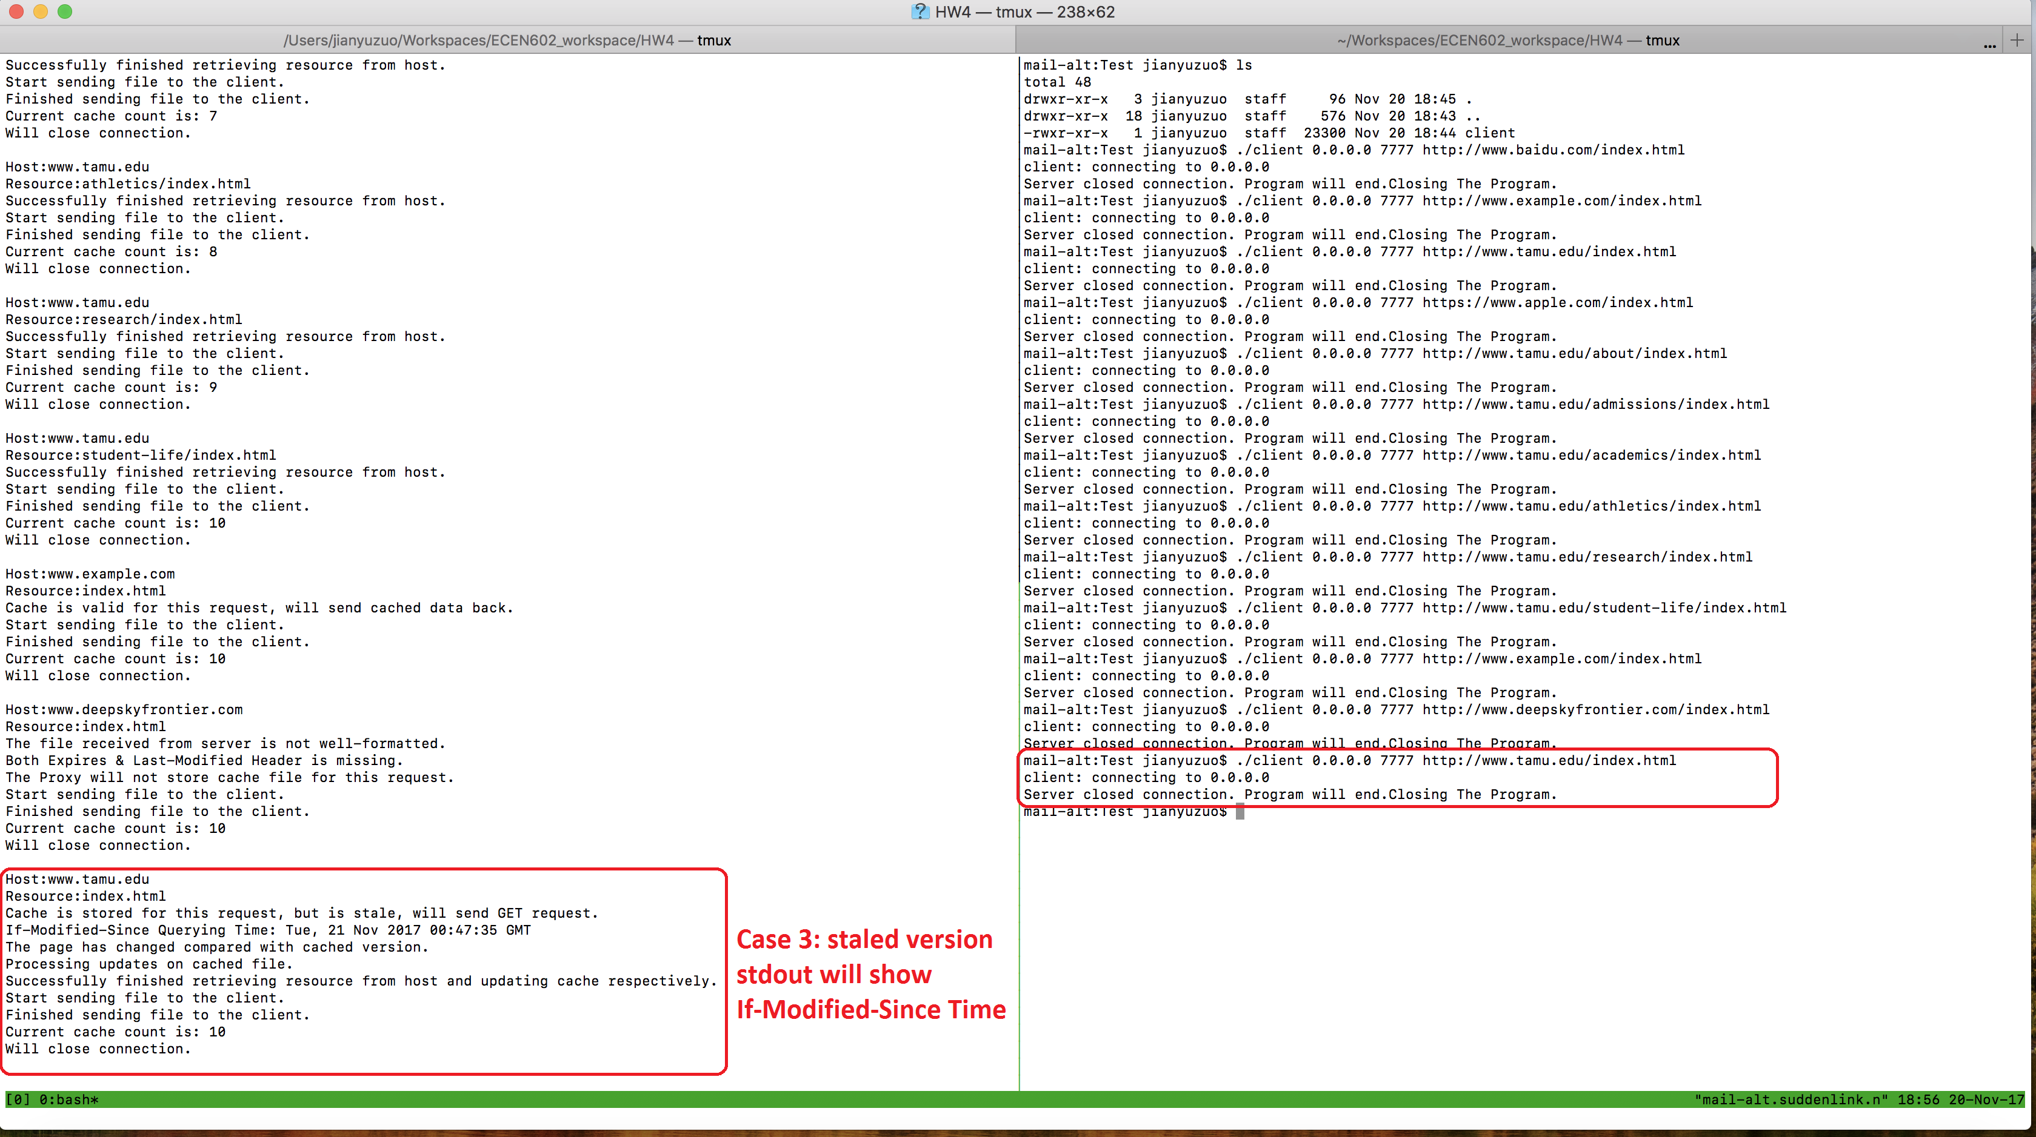

Finally, try a new request that requires caching, which will update the LRU cache:

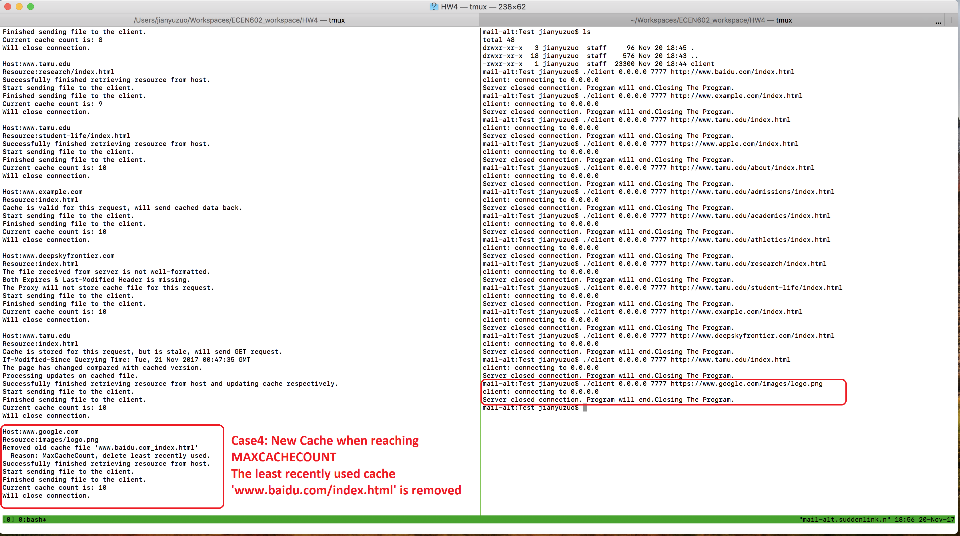

File comparison process:

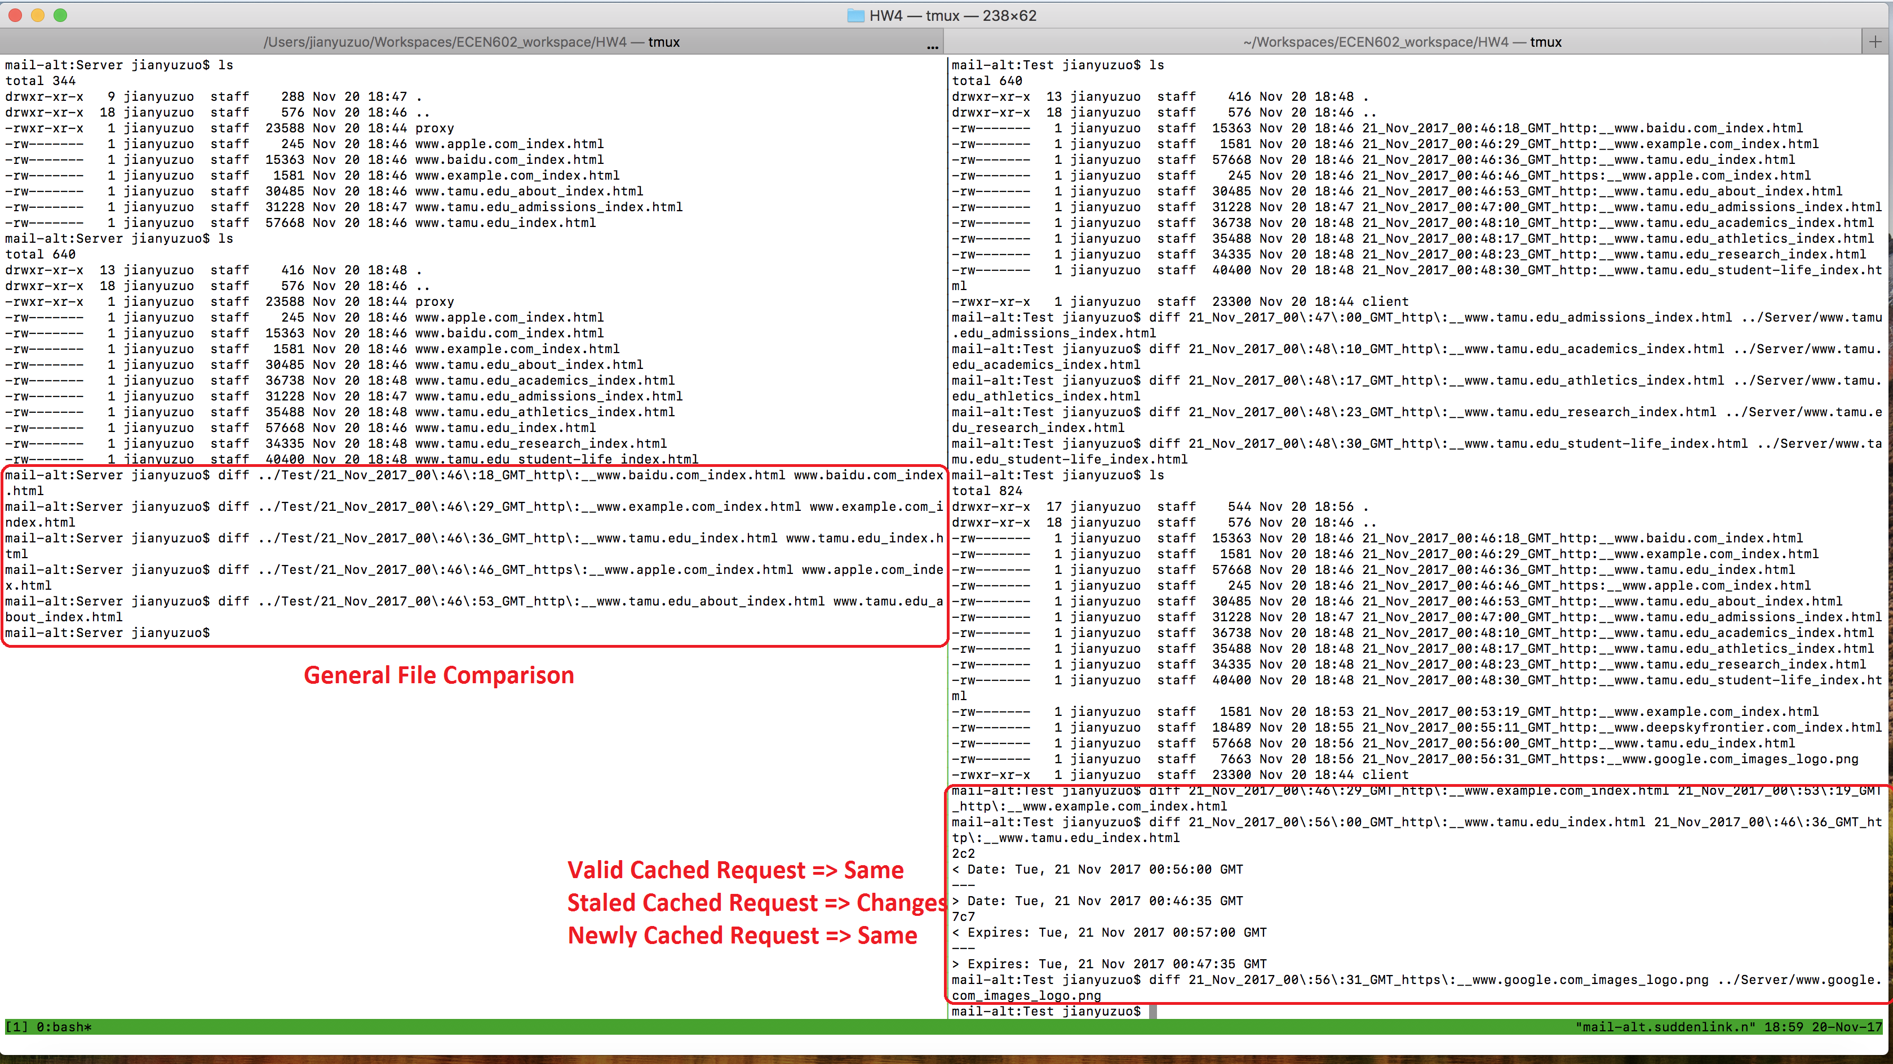

1. We realized that TAMU index page has a quick expiration time (About a minute). In this test suit, for convenience, we’ll set the MAXCACHE count to be 5 for better layouts. The main task for this test case is to test if the LRU logic works properly. Orders listed below are in lowest to highest fashion.

Original Priority Order:

www.baidu.com/index.html

www.example.com/index.html

www.tamu.edu/index.html

www.apple.com/index.html

www.tamu.edu/about/index.html

After Cached & Staled Priority Order:

www.baidu.com/index.html

www.apple.com/index.html

www.tamu.edu/about/index.html

www.example.com/index.html

www.tamu.edu/index.html

After Non-Cached Files Priority Order:

www.example.com/index.html

www.tamu.edu/index.html

www.tamu.edu/admissions/index.html  
www.tamu.edu/academics/index.html  
www.tamu.edu/athletics/index.html

Screenshot for the whole process:

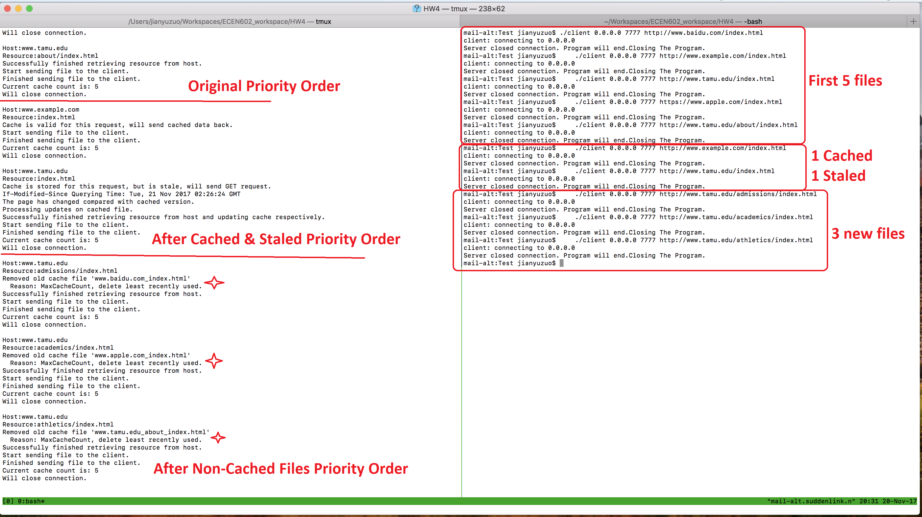

After the above procedures, we tried 3 non-cache files, too. The priority order will not change.

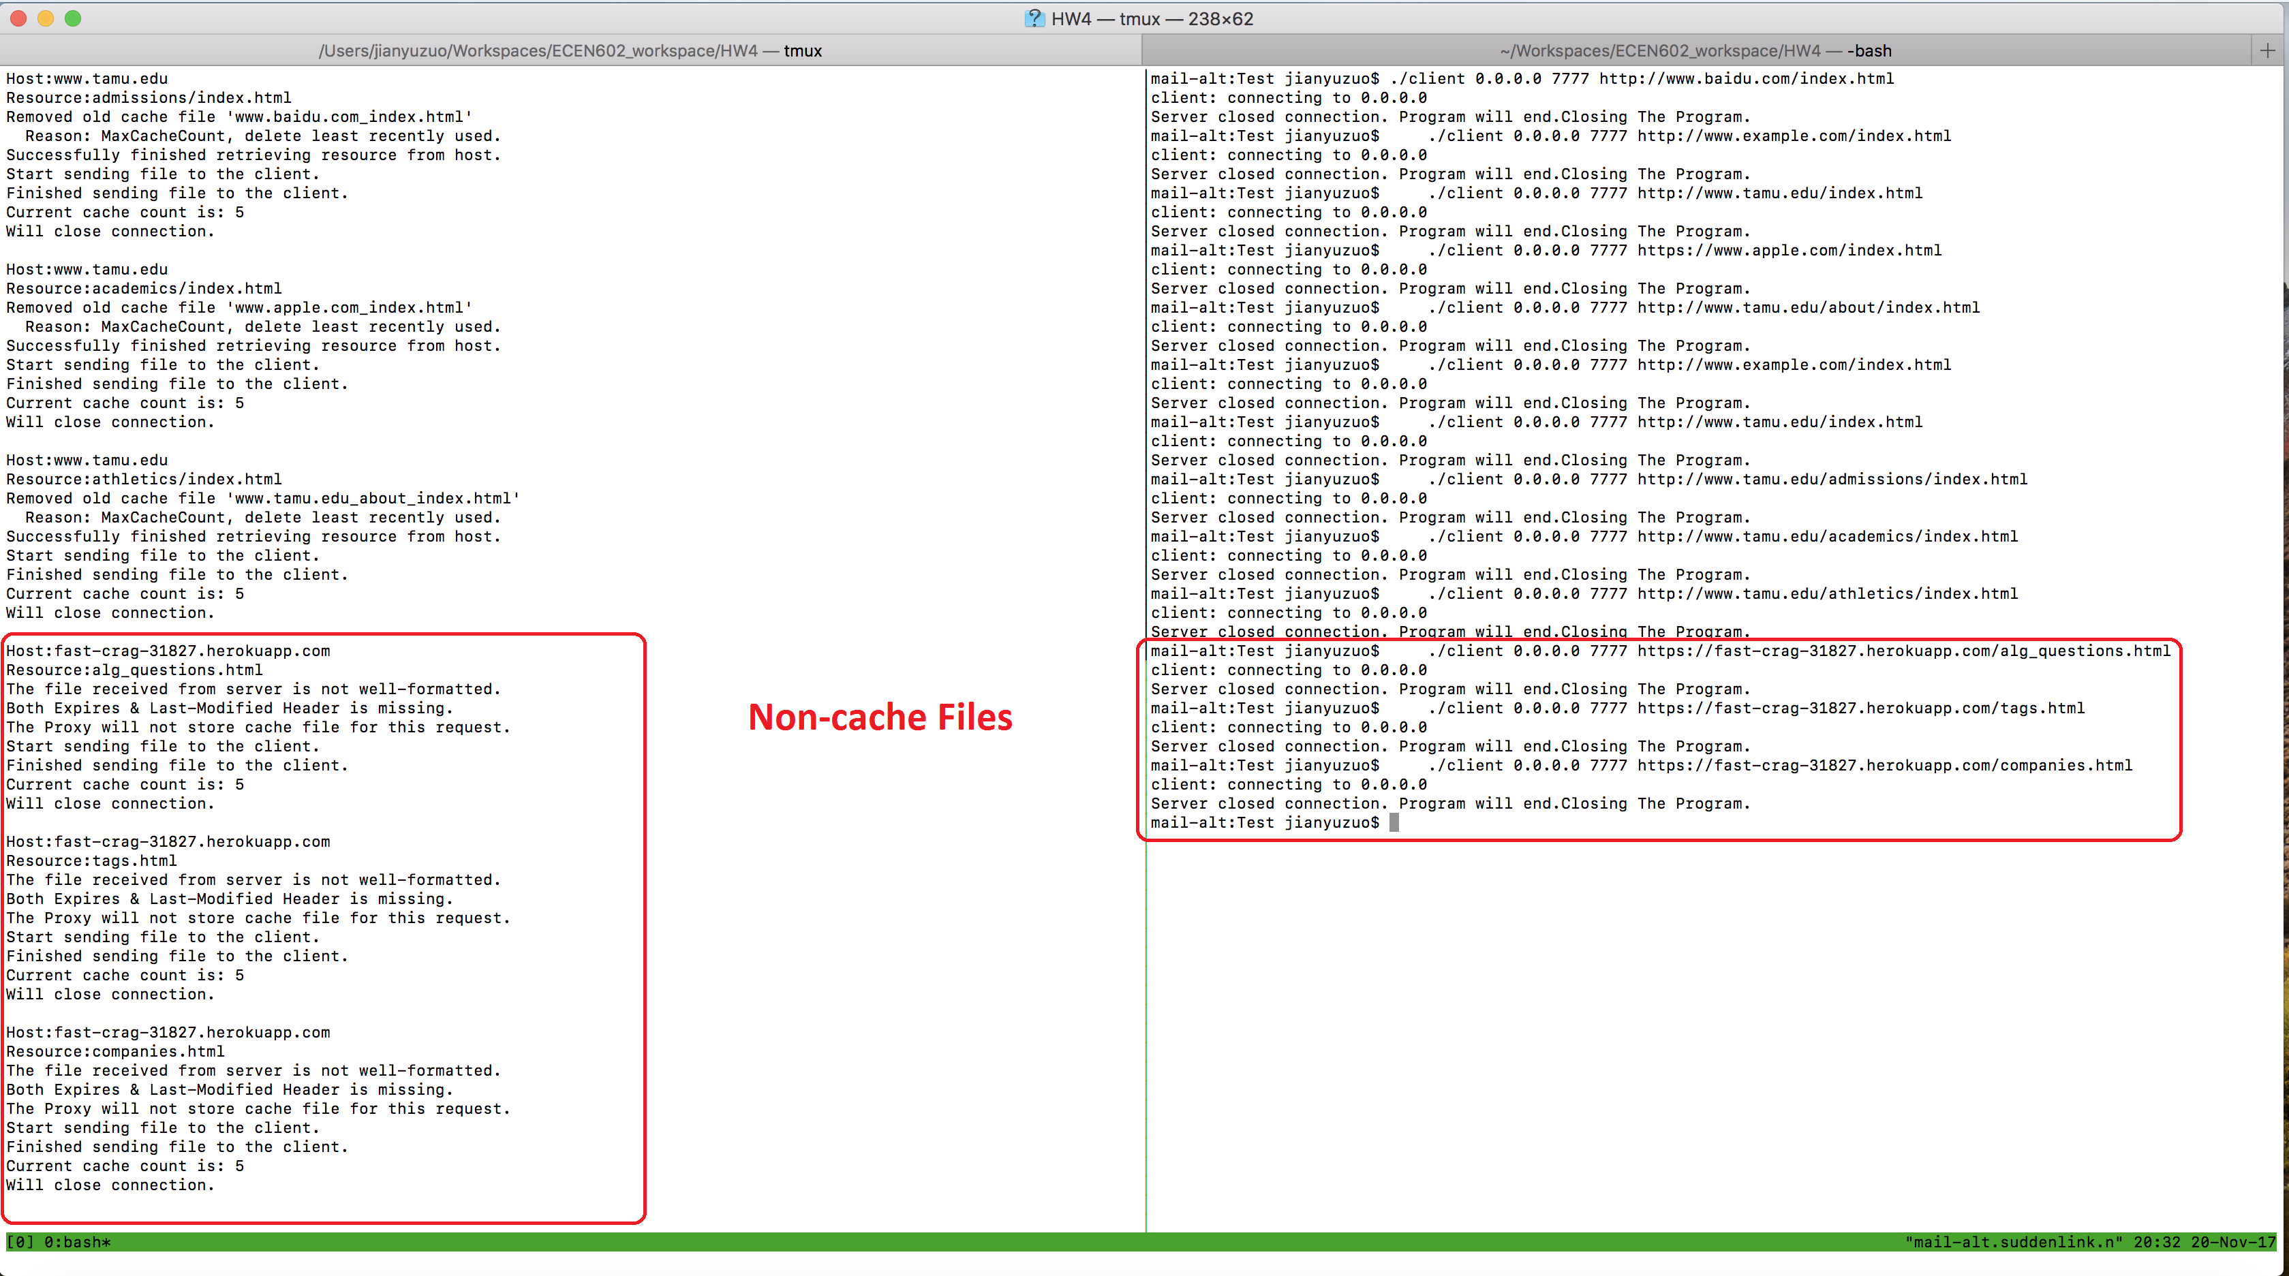

1. The final test case is for 3 users simultaneously connection. We’ll use the default 10 CACHE count. The file from URI below is 10+MB, we’ll try 3 clients fetching the same file and do a file comparison process.

https://fast-crag-31827.herokuapp.com/Big.pkg

After that we run the diff command and these three files are the same as the server cache file.

The following screenshots are the results.

